END OF TERM 3 EXAMS 2022.

S2 PHYSICS

TIME: 2 HOURS

1.(a) Name three fundamental quantities and state their S.I units

Fundamental quantity S.I unit

................................................................... ..............................................................

................................................................... ....................................................................

............................................................................. ...............................................................................

b) Name the most appropriate instrument for measuring each of the following quantity

i) the length of an iron sheet?..................................................................................

ii) the internal diameter of pipe delivering water to an indoor tap

.................................................................................................................

ii) weight of a cork.........................................................................................................

iv) thickness of an iron sheet.........................................................................................

v) 39.6cm3 of a liquid......................................................................................................

2 (a) Define density.................................................................................................................

................................................................................................................................................................

b) Describe an experiment to determine the density of an irregular object that sinks in water. ..............................................................................................................................

..........................................................................................................................................................................................................................................................................................................................................................................................................................................................................................................................................................................................................................................................................................................................................................................................................................................................................................................................................................................................................................................................................................................................................................................................................................................................................................................................................................................................................................................................................................................................................................................................................................................................................................................................................................................................................................................................................................................................................................................................................................................................................................................................................................................................................................................................................................................................................................................................................................................................................................................................................................................................

............................................................................................................................................................................................................................................................................................................................................

c) Convert

i) 672kgm-3 to gcm3.............................................................................................................................

.........................................................................................................................................................................................................................................................................................................................................................................................................................................................................................................................................................................................................................................................................................

ii) 1gcm-3 to kgm3.................................................................................................................................

....................................................................................................................................................................................................................................................................................................................................................................................................................................................................................................................................................................................................................................................................................................................................................................................................................................................................................................................................................................................................................................

3. In the space below draw a labeled diagram of a micrometer screw gauge.

.....

...

....

....

....

4.( a)convert the following quantities as required.

i) 24 days to seconds.

ii) 65km2 to m2

b) (i) Write 56375 to 3 significant figures

ii) Write 3470000 in scientific form

5. (a) Define volume and state its S.I unit...................................................................................................

...........................................................................................................................................................................................................................................................................................................................................

b. find the volume of a cylindrical syringe of length 10cm and diameter 4.8cm

.................................................................................................................................................................................................................................................................................................................................................................................................................................................................................................................................................................................................................................................................

c) Describe an experiment to determine the volume of a small stone...............................................

....................................................................................................................................................................................................................................................................................................................................................................................................................................................................................................................................................................................................................................................................................................................................................................................................................................................................................................................................................................................................................................

SECTION B: ACTIVITY OF INTEGRATION ATTEMPT 2

Activity 1:

**S.2SCENARIO:**Dr.DianaAtwiine,Uganda’spermanentsecretaryintheministryofhealthhasstarted planning for a meeting to host the presidential nation address on“Corona virus” (apandemic) which is to take place on Monday, 23/03/2020. In the budget, she has planned to host500peopleinStatehouseEntebbe.Onconsultationwiththepresidentialadvisoronsocialaffairs,Dr.Dianahasbeenadvisedtoprovidetreatedwaterforwashinghandsbyalltheparticipantssincedoctors have identified washing of hands as a preventive measure to managing the spread of thepandemic Corona Virus. Advisors have provided her with a large metallic tank that will be filledwith that water.Dr. Diana has contacted Juma, a primary two drop out but a business man whosupplies water in Entebbe town and he has asked her how much water she wants so that he canloadhisdeliveryvehicle,unfortunatelyshehasnoanswerbutshehasaskedhimforafewminutesso that she can get the right quantity of water that the tank can accommodate. She has consultedfromthepresidentialadvisor whohasgivenher thetank measurements below.

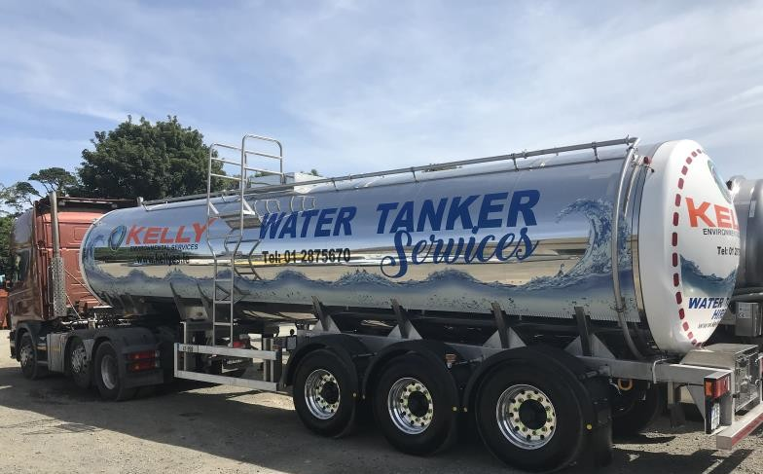

Length = 500cmWidth = 200cmHeight=200cm

On receiving these measurements, Dr. Atwiine has failed to obtain the exact amount of water thetank can accommodate, this has left her puzzled and troubled since Juma is waiting for her reply.AsaS.1studentofMpomaSchool,helpDr.Atwiinecomeupwiththeexactamountofwaterthatthetank canaccommodate to full capacity.

From the knowledge of physics you have gained from Mpoma School, write a letter to Dr. DianaAtwiine specifying to her the physical quantity she is to deal with and what that physical quantitymeans,thepossibleunit(s)sheistoindicateonthequantityofwaterJumaismeanttosupplyandanymeasuringinstrument(s)thatcanbeusedtomeasuresmallquantitiesofthatphysicalquantityin a physics laboratory. In your conclusion, give the exact value indicating the quantity of waterJumais meant to supplywith an appropriateunit thatJumawill beable to understand.

**Activity 2** S.1-2020

***Your grandfather has got a piece which he ought to an investor intending to set up a factory. This old man does not understand any other units of measurement except using a stick which is 12 feet long. The investor on the other hand wants to pay for the land in hectare units, and It is very fortunate that it is a holiday and you are the right person to mitigate this conflict. Assuming the land measures 100 sticks in length and 50 sticks in width, and that 1 𝑓𝑜𝑜𝑡=30c𝑚 and 1 ℎ𝑒𝑐𝑡𝑎𝑟𝑒=10,000𝑚2, help your grandfather to evaluate the total cost of the piece of land if one hectare costs 10millions.***

***END.***

***Activity 3***

Assuming while at your school conducting a physics practical, one of your group members sustained serious blisters on the hand. After successful handling and treatment of the causality, your Head teacher identifies you to present to the entire school the guidelines of proper laboratory use. Write a comprehensive report on which your presentation shall base, clearly indicating the possible dangers that can arise as a result of neglect of the given guidelines.

HAPPY NEW YEAR XXX